404 page
So far things are looking promising, but what happens if we try to request a fact that does not exist? We can find out by changing the id in our path parameter to 99.
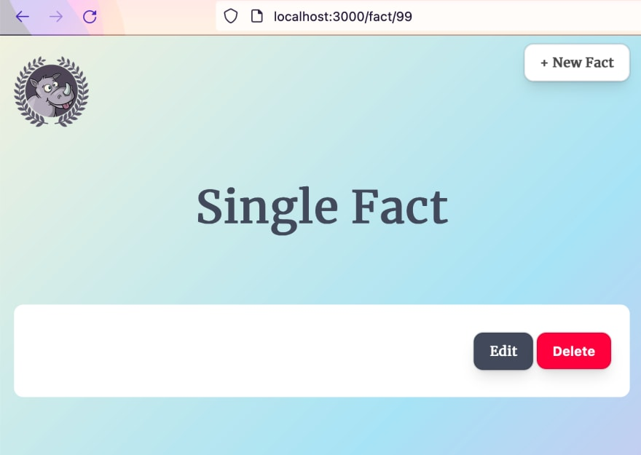
We’re getting an empty result but our show template is still rendering. This behaviour would be confusing to a user because they have no way of knowing what is going on. We can improve the experience by introducing a 404 page. If a fact does not exist, we should render this 404 page instead.
In the cmd/routes.go file, we update the ShowFact handler to return a NotFound when we are unable to retrieve the record. This NotFound handler does not exist yet, so we will need to create it.
func ShowFact(c *fiber.Ctx) error {
fact := models.Fact{}
id := c.Params("id")

result := database.DB.Db.Where("id = ?", id).First(&fact)
if result.Error != nil {
return NotFound(c)
}

return c.Status(fiber.StatusOK).Render("show", fiber.Map{
"Title": "Single Fact",
"Fact": fact,
})
}

func NotFound(c *fiber.Ctx) error {
return c.Status(fiber.StatusNotFound).SendFile("./public/404.html")
}
Then we can go and update our app config in cmd/main.go to also use the NotFound handler. Remember to place this after the other setup, but right before the call to app.Listen
package main

import (
"github.com/divrhino/divrhino-trivia/database"
"github.com/divrhino/divrhino-trivia/handlers"
"github.com/gofiber/fiber/v2"
"github.com/gofiber/template/html"
)

func main() {
database.ConnectDb()

engine := html.New("./views", ".html")

app := fiber.New(fiber.Config{
Views: engine,
ViewsLayout: "layouts/main",
})

setupRoutes(app)

app.Static("/", "./public")

// Set up 404 page
app.Use(handlers.NotFound)

app.Listen(":3000")
}
If we try to test this in the browser now, we will get a blank page. We need to create a 404.html file in our public folder:
touch public/404.html
Then inside the public/404.html file, we can paste some ready-made content from the project repository.
All the markup and styles for this page will be inline. It is a good idea to keep error pages self-contained so they don’t throw additional errors if they are unable to location any external dependencies.
Now when we try to navigate to a route that does not exist, we see our new 404 page:
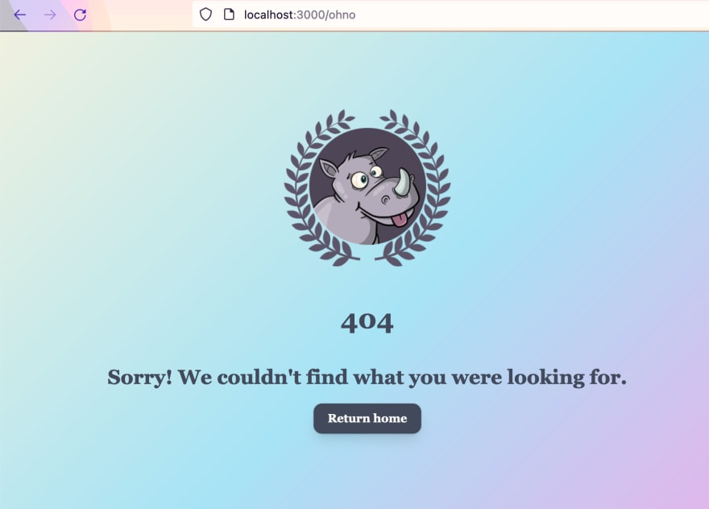
Our show page is done! Let’s keep going.

